
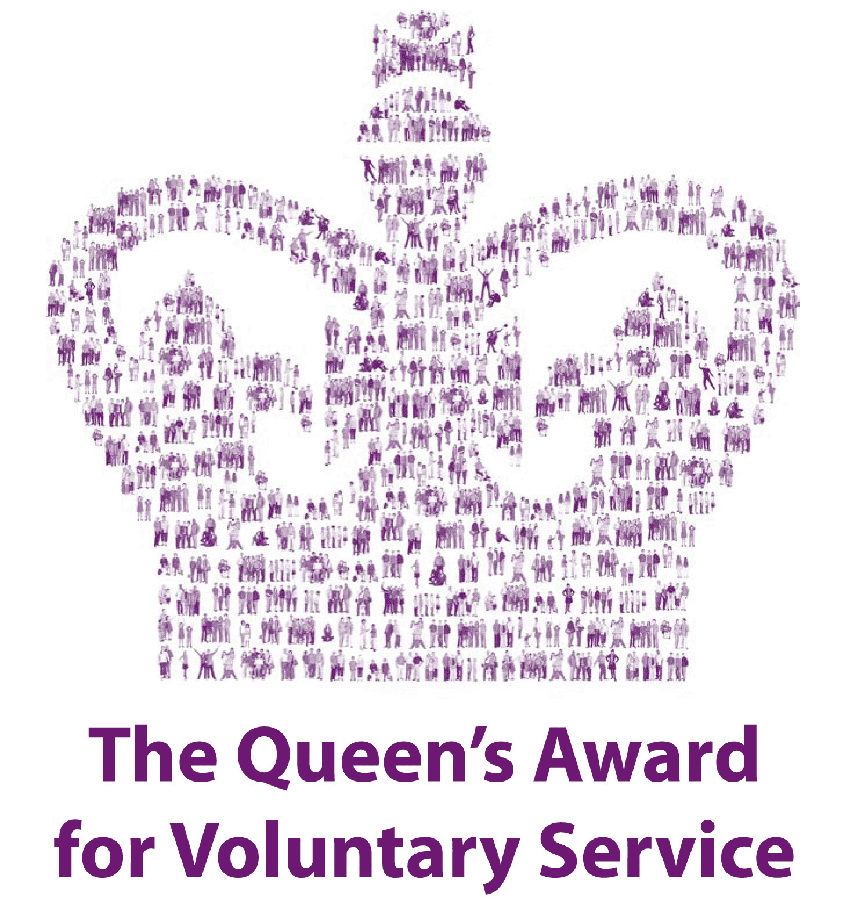
Dartmouth Caring
Dartmouth Health & Wellbeing Centre,
Wessex Way,
Dartmouth, Devon, TQ6 0JL
Supporting Our Community
www.dartmouthcaring.co.uk
Patron – Mary Nightingale
T: 01803 835384
E: enquiries@dartmouthcaring.co.uk

GIFT AID DECLARATION

I confirm I have paid, or will pay, an amount of Income Tax and/or Capital Gains Tax for each tax year (6 April to 5 April) that is at least equal to the amount of tax, that all the charities that I donate to, will reclaim on my gifts for that tax year. I understand that other taxes such as VAT and Council Tax do not qualify.
Name of Charity: DARTMOUTH CARING
Details of Donor:
Title: ……..… Forename(s): …………………………………………………………
Surname: ……………………………………………………………………………..
Address:………..…………………………………………………………………..….………………….....……………………………………………………………………….………………….…………………………………………………………………...
Postcode: ………………………… Telephone: …………………………………….
Email: ……………………………………………………………………………….....

Date: / /
SIGNED: ………………………………………………………………………………
Please treat as Gift Aid donations all qualifying gifts of money made.
Please tick a box below
- All donations I have made today and all donations I make from the date of this declaration until I notify you otherwise
- All donations I have made in the last four years and all donations I make from the date of this declaration until I notify you otherwise

Please notify the charity if you:
1. Want to cancel this declaration
2. Change your name or home address
3. No longer pay sufficient tax on your income and/or capital gains.
4. If you pay Income Tax at the higher or additional rate and want to receive the additional tax relief due to you, you must include all your Gift Aid donations on your Self-Assessment tax return or ask HM Revenue and Customs to adjust your tax code.

